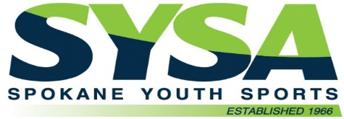
Spokane Youth Sports Association
2023 Financial Assistance Application

Financial Assistance is available for League Play and Camps and is processed in order received.
Complete the following, attach required documents (photo copies only) and return to the SYSA office.
_____________________________________________________________________________

Please print

Applicant Name: Parent/Guardian (not child) _____________________________________________
Street Address City State Zip
Primary Phone Email
Verification of total family income is required.
Please attach copy of the following:

- Reduced/Free Lunch APPROVAL Letter, (not application). Each school age player’s name needs to appear on an approval letter
OR
- Tax Return with child/children listed as dependents.

Application will not be processed without one of these two.
No other forms, letters, coupons etc. will satisfy this requirement.

Family Members at Home  (including self) | Age | Birthdate | Gender | Family Members at Home  (including self) | Age | Birthdate | Gender

Have you applied for SYSA Financial Assistance before? YES _____ NO
Year
Spokane Youth Sports Association Financial Assistance awards are based on demonstrated need;
considering both subjective and objective criteria.

Special circumstance _______________________________________________________________________________
_________________________________________________________________________________________________

Upon completing and signing this application, I certify that have read the application process and that the information supplied herein is true, accurate and complete to the best of my knowledge. Falsification of any information provided for consideration of financial assistance will be grounds for denial or immediate revoke of any awarded financial assistance by SYSA.
SYSA STAFF USE ONLY

________ _________ % discount % parent portion

By:

__________________________________________________________________________
signature date
Spokane Youth Sports Association 800 N Hamilton Suite 201 Spokane, WA 99202 P:(509) 328 – SYSA (7972) Email: receptionist@sysa.com Website: www.sysa.com
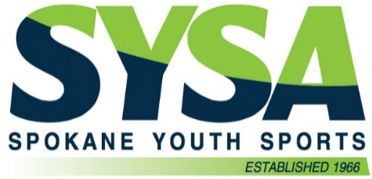
Spokane Youth Sports Association
Financial Assistance Application

SYSA sports activities are intended for all children of the Greater Spokane Area. We strive to keep costs down and to engage the greater community in coming along side us to assist with financial needs. We are thankful you may benefit from these efforts.

Please review the application process and benefits of Financial Assistance 2024

ALL Applicants: Submit Application with Income Verification
- Income Verification limited to one (1) of these two options
  - School lunch letter to include each school-aged player
  - Tax return, name of child/children to be listed as dependents

IMPORTANT things you want to know
- Application must be received one week prior to a registration deadline. Applications received after this may not be processed in time of registration deadline.
- Applications are processed in the order received and may require one week to process.
- Discount must be approved before registration and is applicable only to future registrations, no retroactive discount.
- Registration with Financial Assistance discount NOW available online. Please email receptionist@sysa.com to receive instructions on how to register w/scholarship.
  - Player portion of fees must be paid in full on or before registration deadline.

Award Level
- 50% discount for Recreational league play and Camps.

We are pleased you have chosen SYSA for your sporting activities and we look forward to great season.

Thank you,
SYSA Staff

